**Polymer Installation steps**

**Required software:**

* Node - <https://nodejs.org/en/download/>
* Git for windows - <https://gitforwindows.org/>

After installation, check for node and npm versions in command prompt. And make sure you put the npm path in User Environment variables >> PATH variable. Make sure ONLY npm path is given in the PATH variable.

Go through below link for installation steps but make sure you do below changes BEFORE installing command “bower install Polymer/polymer#^2.0.0” from below link.

<https://www.polymer-project.org/2.0/start/install-2-0#use-bower>

Goto “C:\Users\<username>\AppData\Roaming\npm\node_modules\bower\lib\node_modules\bower-config\lib\util” and edit “**default.js**” and make below changes to properties from defaults variable.

'registry': 'http://bower.herokuapp.com',

'shorthand-resolver': 'https://github.com/{{owner}}/{{package}}.git'

'strict-ssl': false,

Then go ahead installing Polymer 2 . You should see something like this:

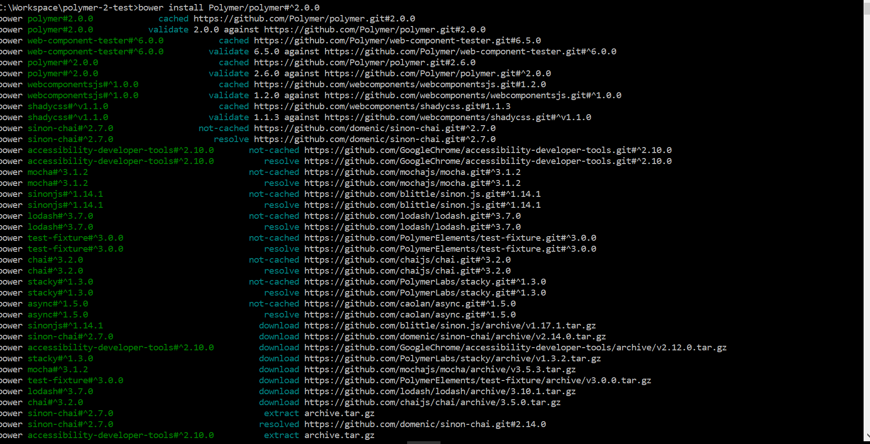

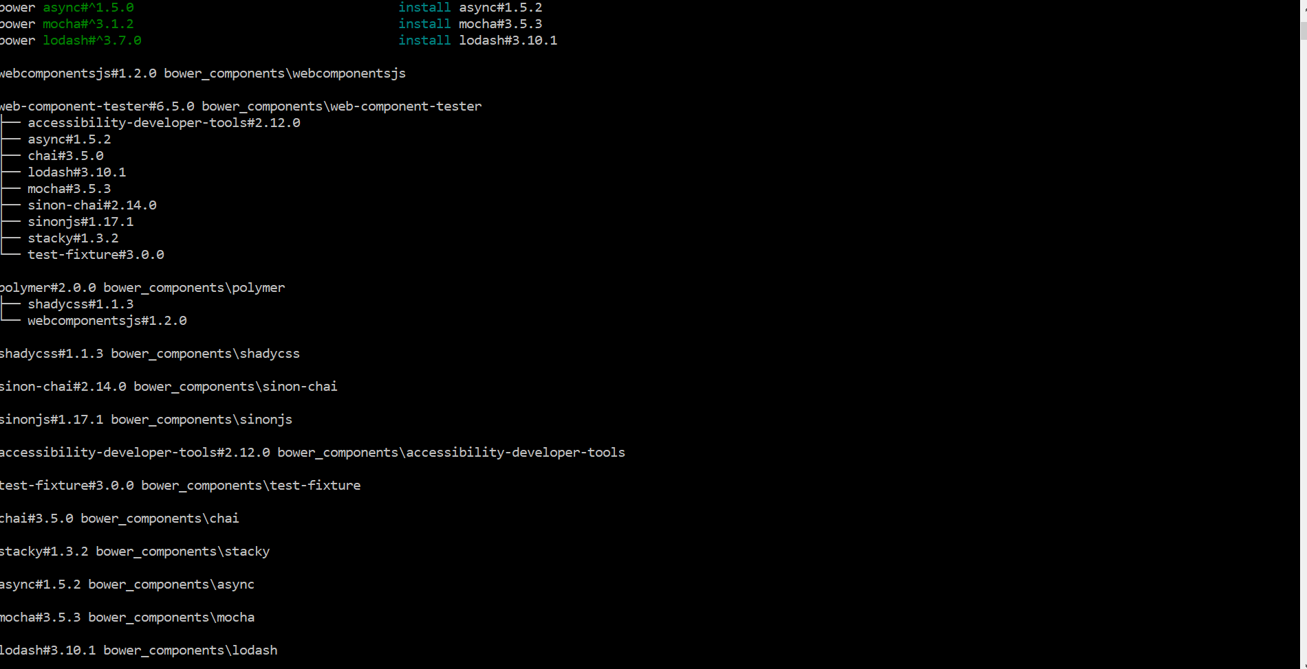

Now Run **bower install paper-input**



Run **bower install iron-ajax**



And continue with installation and on executing “**polymer serve**” command and on triggering the localhost url as seen in the command prompt (screenshot below), you should see the output from the default custom element polymer has created.

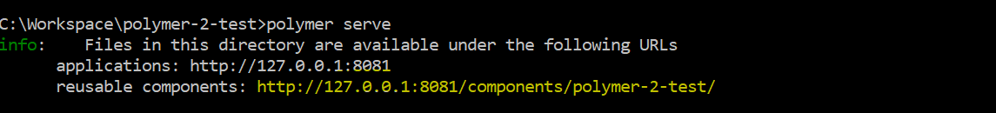

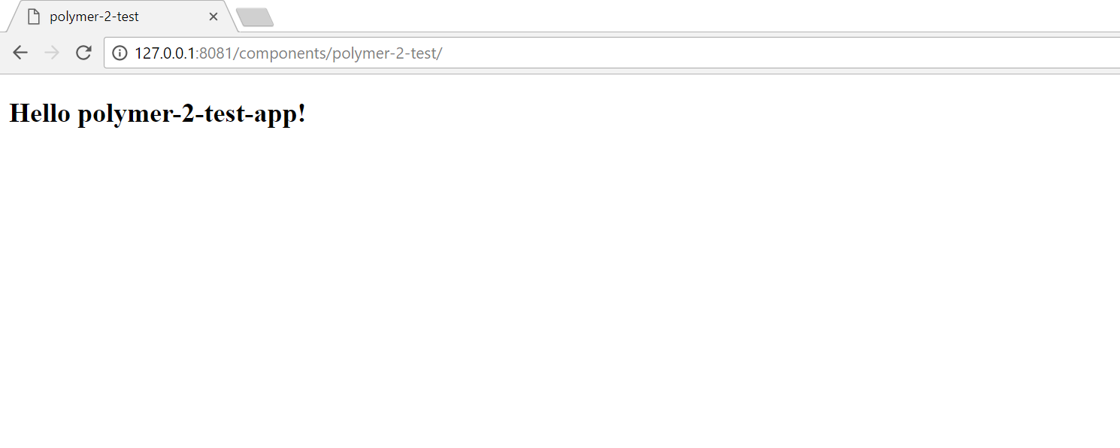

Open the project in your editor like Eclipse/STS/IntelliJ and can start doing changes.